Sample Manuscript
Full First author’s name¹*, Full Second author’s name², and Full Third author’s name³
¹ Affiliation, City, Country
² Affiliation, City, Country
³ Affiliation, City, Country

ABSTRACT

Insert abstract text here. The abstract should concisely summarize key findings of the paper and should consist of a single paragraph containing no more than 300 words. Please use 11 pt. Times New Roman font with single spaced lines and 1-inch margins. The full length of the paper should not exceed 15 pages.

INTRODUCTION

Insert introduction text here. Please use the number-in-bracket [1] reference format throughout the paper.

MAIN HEADING

Insert main body text here.

Secondary Heading
The secondary heading uses 11 pt. italic type.

Equations
Please number all equations as the sample Eq. (1).
 | $$A=πr^{2}$$ | (1)

Tables
Table captions appear above the table. See Table 1 below.

Table 1. Word font size and formatting that you can use for your manuscript
Formatting style name: | Brief description:
Paper Title | 18 pt. bold
Authors | 14 pt.
Affiliations | 11 pt. italic
ABSTRACT TITLE | 11 pt. bold
Abstract body text | 11 pt.
MAIN HEADING | 11 pt. bold
Body text | 11 pt.
Figure caption | 11 pt.
Table caption | 11 pt.
Secondary Heading | 11 pt. italic bold
ACKNOWLEDGEMENTS | 11 pt. bold
REFERENCES | 11 pt. bold

Figures
Figure example is shown in Fig. 1.
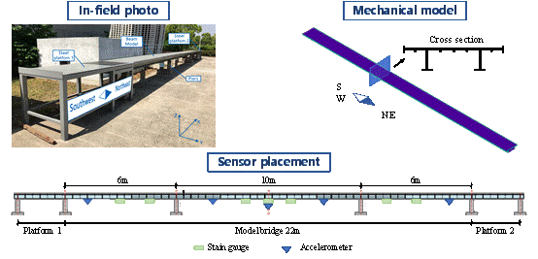

Fig. 1. Welcome to IC-SHM 2022

ACKNOWLEDGEMENTS

Insert acknowledgements here (if applicable).

REFERENCES

- A.B.Lastname., C.D.Lastname, E.F.Lastname, Advances in Computer Vision-Based Civil Infrastructure Inspection and Monitoring, Engineering 5 (2) (2019) 199–222, https://doi.org/10.1016/j.eng.2018.11.030.

*Corresponding Author Email: **@**; phone; fax

